Kamvalethu Luthando Mdanjelwa

ST10377628

PROG6212 POE Part1

Table of Contents

Report 2

Color Scheme: 2

Database Structure: 2

Assumptions and Constraints 3

UML Class Diagram 4

Business Rules of UMl Diagram 4

Project Plan 5

Project Plan Diagram: 5

Graphical User Interface 6

GitHub link: 7

## Report

The Contract Monthly Claims System is a system that will be utilized by lecturers and college/university administration departments and as such the approach to the design of this system will not be to have it aesthetically complicated but to mainly intake information and convey said information to other departments in the most simplistic manner.

### Color Scheme:

Background- The background color scheme will be Gray(D9D9D9)

Text- The text will be displayed in black in order or contrast the background and be more readable

Button- The button backgrounds will be a shade of blue(8899EF), with text being white

Fields- The fields are going to be shade of white(FAF2F2)

### Database Structure:

The database will consist of three tables/classes that will each consists of information of Lecturer, Programme Coordinator, Track and Academic Manager

**Tables/Classes:**

Lecturer

ProgCoordinator

Track

AcManager

**Attributes:**

**Lecturer**-

* String LName
* String LSName
* Int LecturerID(PK)
* Int DaysAbsent

**ProgCoordinator**-

* Int LectureID(FK)
* Int ProgCoID(PK)
* Int DaysWorked
* Int ClaimNo
* Bool Status

**Track**-

-String Status

-int ClaimNo(FK)

-int ProgCoordinatorID(FK)

**AcManager**-

-int ProgrammeCoordinator(FK)

-int TotalAmount

-String Status(FK)

-LecturerID(FK)

### Assumptions and Constraints

This system is that only the departments mentioned in the document will be interacting with the system, those departments being Lecturer, Programme Coordinator and the Academic Manager, the system should be able to display all the information for the lecturer to the Programme Coordinator who will approve or reject the claim and then the Programme Coordinator reports to the Academic Manager who will then arrange the payment details back to the lecturer and can also accept or reject the claim if need be. The system will have support for document uploads. The Lecturer can not update or alter information after submission.

## UML Class Diagram

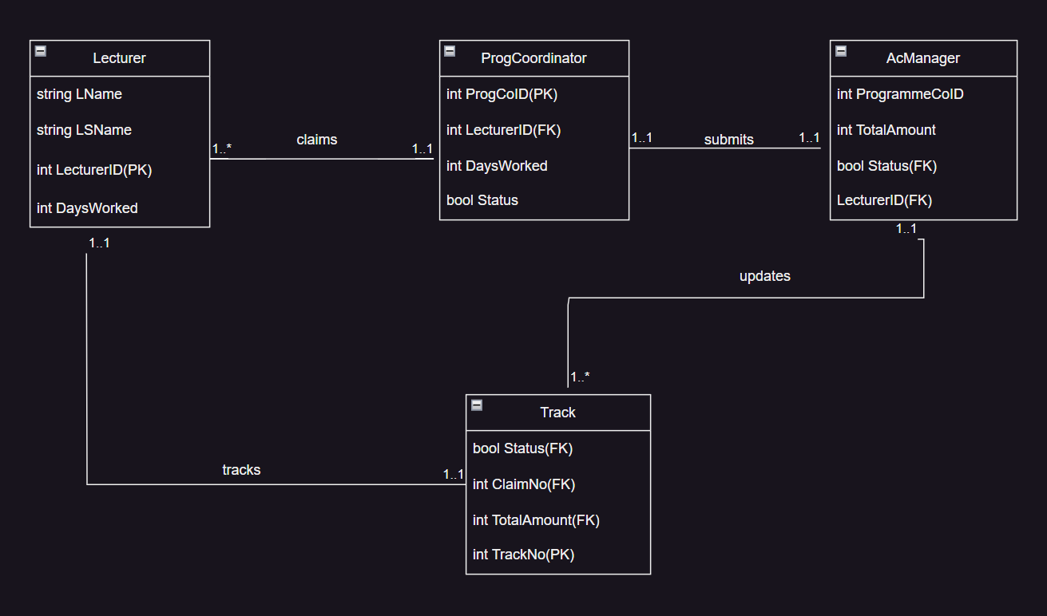

### Business Rules of UMl Diagram

The diagram above depicts that:

One or More Lecturers can **claim** to the One and Only One Programme Coordinator.

One and Only One Programme Coordinator then **submits** the information to One and Only One Academic Manager.

One and Only One Academic Manager has the ability to **update** One or More Tracks.

One and only One Lecturer can **track** One and Only one Track.

## Project Plan

### Project Plan Diagram:

The diagram above depicts the sharing and responsibilities of the developments of the project along with deadlines and due dates along with a Gannt chart and predecessors being highlighted by the yellow lines.

## Graphical User Interface

This is the page that the lecturer will be able to interact with, allowng for them to input their details, upload documents and to also track their claims status.

This is the screen that the Programme Coordinator will then gather that information by searching for the lecturer and be able to approve or reject the application.

This last screen will then be of the Academic manager who will be making the calculations of the hourly rate and the total claim amount and they can also approve or reject the claim made by the lecturer.

GitHub link: <https://github.com/K-Mdanjelwa/PROG6212POE>